|  |  |  |  |
| --- | --- | --- | --- |
| Dataset | Directory | Description | Source |
| lung_gene | lung_gene<- read.table("~/DLSPH/CHL5208/data/lung_gene.txt",  header = TRUE, sep = "\t"  ) %>% data.frame() | Gene expression dataset | Original from TCGA |
| lung_phe | lung_phe <- read.table("data/phenotype.txt",  header = TRUE, sep = "\t"  ) %>%  data.frame() | Phenotype data | Original from TCGA |
| clinical_dat | clinical_dat <- read_delim("data/lusc/clinical.tsv",  delim = "\t", escape_double = FALSE,  trim_ws = TRUE  ) | Demographic info | Original |
| Work_dat1 | work_dat1 <- inner_join(clinical_dat1, phe_gen_dat,  by = c("case_submitter_id" = "X_PATIENT")  ) %>%  filter(!is.na(OS.time)) %>%  filter(!(OS == 1 & OS.time == 0)) %>%  filter(!(OS == 0 & OS.time == 0)) | All data  996 samples,  Used **for Univariate data analysis** |  |
| **Uni_dat** | uni_data <- work_dat1 %>%  select(OS,OS.time,OS.time_yr,  OS.time_month,  project_id,  age_at_diagnosis,  gender,race,  ajcc_pathologic_stage,cancer_stage) | 一个work_dat1的subset，感觉更轻便一点 |  |
| Work_dat2 | work_dat2 <- work_dat1 %>%  filter(!is.na(age_at_diagnosis)&!is.na(cancer_stage)) | 这里我筛选了age and cancer stage not na的，供958例，用于后面的real data analysis, 因为我们有adjusted for demo info |  |
| Gene_dat | gene_dat <- work_dat2 %>%  select(-colnames(.)[!(colnames(.)%in% gene_names)]) %>%  apply(.,2,as.numeric)  colnames(gene_dat) <- rlang::set_names(paste0('X_',  make.names(colnames(gene_dat))))# Assuming your independent variables start from the third column | 这里我把gene 数据选出来了 变为numeric的 |  |
| Outcome_dat | outcome_dat <- work_dat2 %>% select(OS.time_month,OS) %>%  rlang::set_names("time","status") | Outcome 数据为一个数据集 |  |
| Cov_dat | cov_dat <- work_dat2 %>%  select(age_at_diagnosis,cancer_stage_cat2) %>%  rlang::set_names('age_at_diagnosis','cancer_stage') | Covariate作为一个数据集 |  |
| **Cox_dat** | cox_dat <- cbind(outcome_dat,cov_dat, gene_dat) | 所有需要的列放在一起，后面的分析就是基于这个数据集的 |  |

Then, 基于cox_dat，adjusting for age and cancer stage, univariate data analysis was done one each gene, and the output was stored in **uni_cox_res2.rdata,**

**save(uni_cox_res2,file = 'output/uni_cox_res2.rdata')**

further, the top 200 significant snps were selected for the following analysis

|  |  |  |  |
| --- | --- | --- | --- |
|  |  |  |  |
| Uni_cox_res2 | save(uni_cox_res2,file = 'output/uni_cox_res2.rdata') |  |  |
| Uni_cox_top200 | uni_cox_top200 <- uni_cox_res2%>%  arrange(BH) %>%  filter(BH <= BH[200])  save(uni_cox_top200,file="**output**/uni_cox_top200.rdata") | Top 200 univariate data analysis output |  |
| Reg_dat | reg_dat <-cox_dat %>%  select("time", "status", "age_at_diagnosis", "cancer_stage",  (uni_cox_top200$var_name)) | Subset of cox_dat 只有**200个genes** |  |
| trainingSet  and  testSet | set.seed(20240123)  trainIndex <- createDataPartition(reg_dat$status,  p = 0.8, list = FALSE)  trainingSet <- reg_dat[trainIndex,]  testSet <- reg_dat[-trainIndex,] |  |  |
| lung_boot_lst | lung_boot_lst <- boot_f1(  df = trainingSet,  nboot = 100,  boot_ft = 20,  gene_index = 5,  cov_vars = c('age_at_diagnosis','cancer_stage'),  seed = 20231106  ) | 767 obs, 200 genes |  |

Simulation set up

|  |  |  |  |
| --- | --- | --- | --- |
|  |  |  |  |
| Sim_set1 | boot_ft1 <- c(5:10)  boot_ft2 <- c(5:15)  boot_ft3 <- c(5:20)  sim_set1 <- lapply(boot_ft1,function(boot_ft){  boot_f (df = sim_set[[1]],  nboot = 100,  boot_ft = boot_ft,  seed = 20231106)  }) | Feature=25时，取不同的boot_ft (bootstrap set里面的feature数量) 超参数 |  |
| Sim_set2 | sim_set2 <- lapply(boot_ft2,function(boot_ft){  boot_f (df = sim_set[[2]],  nboot = 100,  boot_ft = boot_ft,  seed = 20231106)  }) | Feature = 50时，取不同的boot_ft超参数 |  |
| Sim_set3 | sim_set3 <- lapply(boot_ft3,function(boot_ft){  boot_f (df = sim_set[[3]],  nboot = 100,  boot_ft = boot_ft,  seed = 20231106)  }) | Feature=100时，不同的bootstrap feature 超参数 |  |
| Reg_dat50 | /04_top200_selection | Here I generated, which is a subset of reg_dat with the top 50 significant genes , as a starting point |  |

A document of errors installing packages on CCDB:

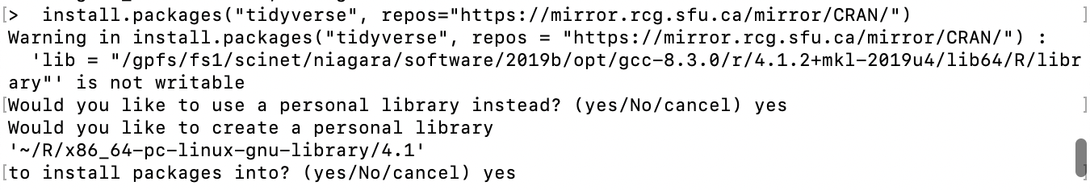

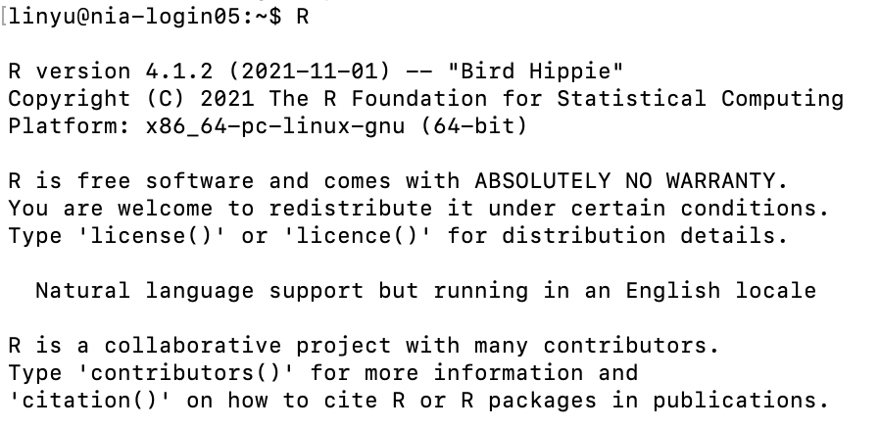

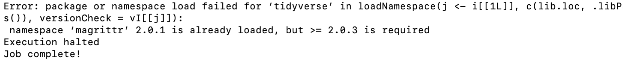

The downloaded source packages are in

'/tmp/RtmpLSGCjC/downloaded_packages'

magrittr

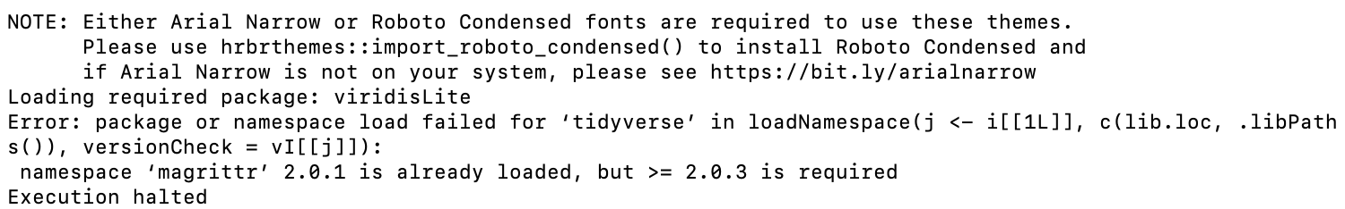

# Unload the 'caret' package

library(tidyverse, unload = TRUE)

# Install or update the 'generics' package

install.packages("magrittr") # Replace with the correct version if needed

# Load the 'generics' package

library(magrittr)

# Load the 'caret' package

library(tidyverse)

# Check the version of the 'generics' package

packageVersion("generics")

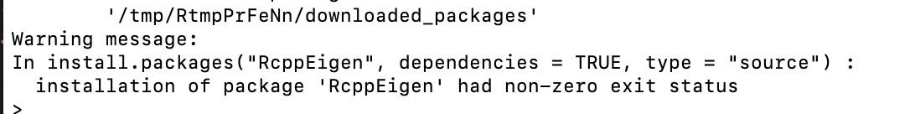

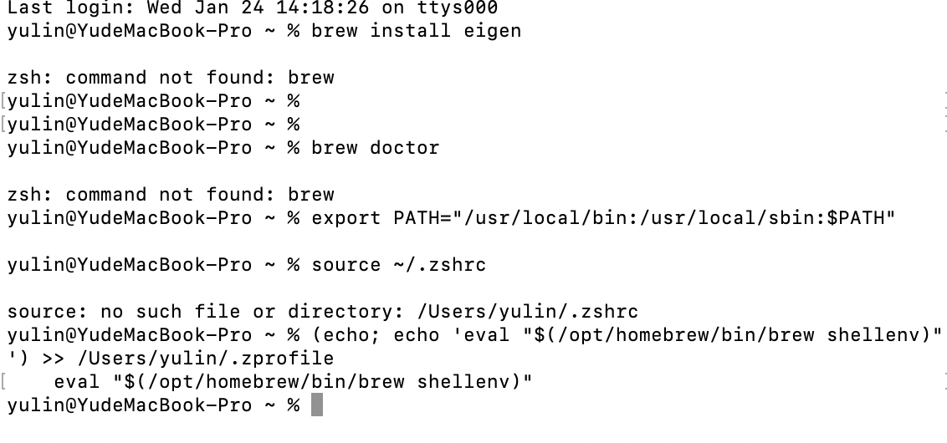

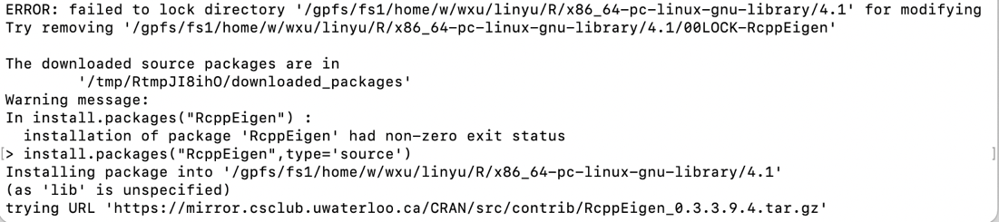

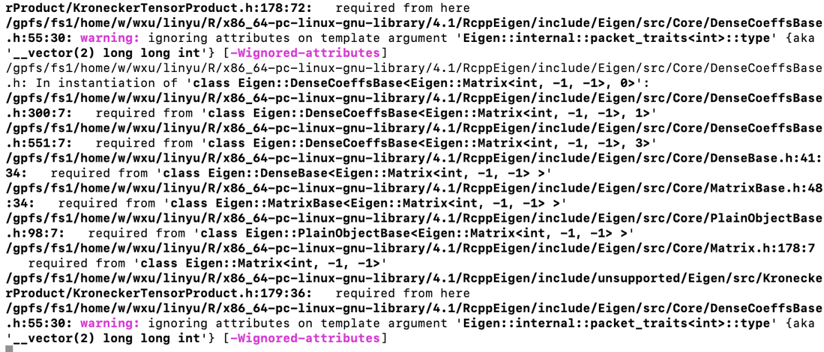

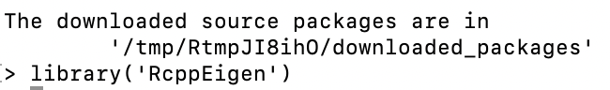



Loading required package: Matrix

Error: package or namespace load failed for ‘glmnet’ in dyn.load(file, DLLpath = DLLpath, ...):

unable to load shared object '/gpfs/fs1/home/w/wxu/linyu/R/x86_64-pc-linux-gnu-library/4.1/glmnet/libs/glmnet.so':

libgfortran.so.5: cannot open shared object file: No such file or directory

Lmod is automatically replacing "gcc/8.3.0" with "intel/2019u4".

